Tomorrow's Architects: ARB consultation on education and training reforms
Closing date 10 May 2023
- What is your name?
- What is your email address?
- What is your organisation?
Please tick this box if we should consider this a formal response on behalf of your organisation, as in, that represents the views of your organisation in an official capacity?
- May we publish your response?
  - Yes, you can publish my response in full
  - Yes, you can publish my response anonymously
  - No, you cannot publish my response
- Would you like to be kept informed about the outcome of this consultation?
  - Yes
  - No
- Which of the following most closely describes your place of residence?
- Which ethnic group do you belong to?
- How would you describe your gender?
- Which of the following best describes you?
  - Academic (registered architect)
  - Academic (other)
  - Registered Architect
  - Architectural assistant, designer or consultant (not Part 3 qualified)
  - Architecture Student – undergraduate (studying Part 1)
  - Architecture Student – graduate (studying Part 2)
  - Architecture Student – Part 3 candidate
  - Elected political representative e.g. councillor or MP
  - Member of the public
  - Other built environment professional
  - Other
- Do you have any physical or mental health conditions or illnesses lasting or expected to last 12 months or more?
  - Yes
  - No
  - Prefer not to say
  - Is there anything further you would like to tell us about your conditions or illnesses

New regulatory framework
ARB is proposing to change the framework for educating and training architects. Through new framework we would set requirements at two stages only: 1. Academic Outcomes that could be achieved through a master’s degree or equivalent, and 2. Practice Outcomes that could be achieved through professional experience. This would replace the current Parts 1, 2 and 3 approach and we would no longer accredit undergraduate degrees.
Our aim is that this new framework will increase flexibility and the opportunity for innovation, introduce new entry points to the profession, and continue to develop the competency of the profession in the future. You can see the vision we shared in 2021 here.

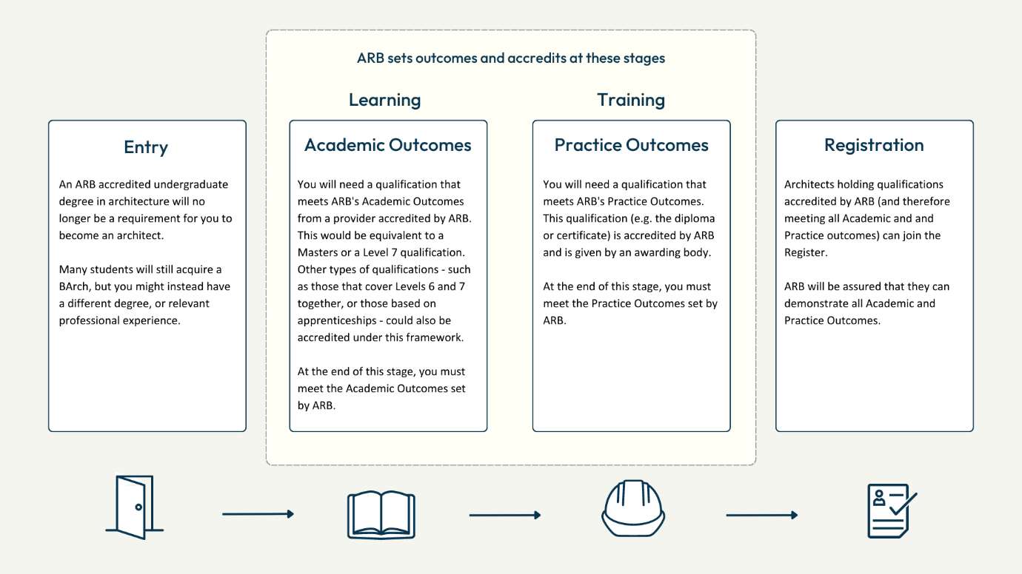
13. To what extent do you agree that ARB’s proposed regulatory framework will meet our aim and help to achieve our vision?
a. Strongly agree
b. Agree
c. Neither agree nor disagree
d. Disagree
e. Strongly disagree

Please feel free to explain your response. We’re particularly keen to hear your views on the new framework regarding:

- whether the new, wider range of entry points will improve accessibility into the profession;

- whether the move to outcomes will help to improve innovation and flexibility for learning providers;

- any funding or wider resource implications (in any part of the UK) as a result of our proposal to accredit only at two points or the setting of new competency outcomes.

- whether this new regulatory framework is compatible and will work well with apprenticeships and other work-based qualifications that may emerge in the future.

Professional practical experience
Architects will need a qualification that demonstrates they have met ARB’s Practice Outcomes. By focusing on outcomes, we would no longer require a minimum duration of professional practical experience in order to gain that qualification.
14. To what extent do you agree with ARB’s proposal to no longer require a minimum duration of practical experience?
a. Strongly agree
b. Agree
c. Neither agree nor disagree
d. Disagree
e. Strongly disagree
Please feel free to explain your response:
Competency Outcomes
In our proposed new framework, skills, knowledge, experience and behaviours are defined through five competency areas:
- Professionalism and Ethics
- Design
- Research and Evaluation
- Contextual and Architectural Knowledge
- Management Practice and Leadership
You can read the competency outcomes here.
15. To what extent do you agree that each competency area accurately reflects the skills, knowledge, experience and behaviours someone must demonstrate in order to practise as an architect?
Strongly agree | Agree | Neither agree nor disagree | Disagree | Strongly disagree
Professionalism and Ethics
Design
Research and Evaluation
Contextual and Architectural Knowledge
Management Practice and Leadership
If you would like to explain the reason for your response, please do so here. If your comments concern a specific outcome, it would be helpful if you referred to the number of that outcome.
16. Is there anything missing from our draft outcomes?
Standards for learning providers
The standards for learning providers (e.g. universities) aim to help to ensure that students being awarded the qualification will have met the outcomes; that there are sufficient resources in place to deliver the qualification; and that there is an organisational culture that will ensure consistent quality and support students.
You can read the standards here.
17. To what extent do you agree that each standard will deliver ARB’s aims?
 | Strongly agree | Agree | Neither agree nor disagree | Disagree | Strongly disagree
Educational content
Assessments
Human resources
Teaching and learning resources
Governance and leadership
Student support
If you would like to explain the reason for your response, please do so here. If your comments concern a specific standard, it would be helpful if you referred to the number of that standard..
18. Is there anything in our draft standards that you particularly like or dislike, could be improved, or is missing?
General Rules and Accreditation Committee Rules
ARB’s draft rules set out how we will comprise and run the new accreditation process and the role of the new committee that will decide whether an institution’s qualification can receive accreditation. These changes to our rules set out the technical process by which we will implement new government legislation, which moves ARB’s decision-making responsibilities from the ARB Board to a new ARB committee. Whilst consulting on the Rule changes necessary for new regulatory framework and accreditation process, we have also taken the opportunity to consult on other changes to our General Rules.
You can read about the Accreditation Rules here and the General Rule changes here.
19. Do you have any suggestions about how we can improve the draft rules?
Transitioning to the new framework
ARB intends to implement the new accreditation process over a period of three years, with the intention that by September 2027, all accredited courses will meet the new outcome-based framework. You can read about our proposed transition plans here.
20. Are there any risks or opportunities you would like to raise about our implementation date for the new framework?
21. Is there any additional guidance you would like ARB to provide?
Inclusivity of the proposals
One of our aims in changing the structure of architectural education is to improve inclusivity. We have heard that whilst the current system has produced thousands of excellent architects, it’s created significant barriers to some people becoming architects at all.
We believe that removing the regulatory requirement for an undergraduate degree in architecture will help to widen access to the profession. It would mean that, to embark upon the path to becoming an architect, people could have one of a range of different undergraduate degrees rather than a specific, accredited degree in architecture. Some people may not have a degree at all, but be able to demonstrate professional experience that a learning provider deems appropriate and sufficient to enable them to achieve the learning outcomes.
We also note the feedback from many students, particularly female students and those from minority ethnic groups, that they have suffered discrimination or mistreatment during their education and training. Our new standards for learning providers have been designed to strengthen regulatory oversight.
22. To what extent do you agree that our proposals will help to widen access to the profession?
a. Strongly agree
b. Agree
c. Neither agree nor disagree
d. Disagree
e. Strongly disagree
23. To what extent do you agree that our proposals will help strengthen oversight of learning providers to create a better learning environment for students?
a. Strongly agree
b. Agree
c. Neither agree nor disagree
d. Disagree
e. Strongly disagree
24. Is there any feedback you wish to give about a positive or negative impact on equality, diversity and inclusion within our proposals?
Almost done…
You are about to submit your response. By clicking 'Submit Response' you give us permission to analyse and include your response in our results. After you click Submit, you will no longer be able to go back and change any of your answers.
If you provide an email address you will be sent a receipt and a link to a PDF copy of your response.

